Topic – Content Recommendations System using Hash Table
Tripti Vishwakarma
Colorado State University Global
Course Code: CSC506 1
Dr. Dong Nguyen
Dec 15, 2024

Title: Optimizing Social Media Content Recommendation Systems Using Hash Tables
Introduction
Social media platforms generate massive amounts of data, necessitating advanced systems to deliver personalized content to users. The primary goal of this project is to design a content recommendation system using hash tables, which can efficiently handle large datasets and provide real-time updates. By leveraging the fast retrieval capabilities of hash tables, the system aims to enhance user experience by offering timely and relevant content.
Program Purpose
The hash table implementation serves as the backbone of the recommendation system, allowing for:
- Efficient Data Management: With average O(1) time complexity for search and insertion operations, hash tables facilitate quick access to user preferences and content data.
- Scalability: The system can scale to accommodate a growing user base and increasing content volume, ensuring consistent performance.
- Real-Time Updates: As user interactions and content availability change, hash tables enable the system to swiftly update recommendations.

Justification for Using Hash Tables
- Fast Retrieval: Hash tables provide constant average-time complexity (O(1)) for search operations, which is vital for retrieving user-specific content recommendations quickly.
- Dynamic Updates: The ability to perform insertions and deletions in O(1) time on average supports the need for real-time updates as user preferences and content change.
- Memory Efficiency: While hash tables may have higher memory consumption due to potential collisions, their structure allows efficient use of space for large datasets when managed properly.

Time Complexity Analysis
- Insertion: Average-case O(1), worst-case O(n) due to collisions.
- Search/Retrieval: Average-case O(1), worst-case O(n).
- Deletion: Average-case O(1), worst-case O(n).
Real-Life Factors Impacting Hash Table Performance
- Hash Function Quality: A well-designed hash function minimizes collisions by evenly distributing keys across the table. Poor hash functions can lead to clustering and increased retrieval times.
- Load Factor Management: Maintaining an optimal load factor is critical. High load factors can increase collisions, while low load factors may waste memory.
- Collision Resolution: Choosing effective collision resolution strategies, such as chaining or open addressing, impacts both performance and memory usage.
- Memory Overheads: Hash tables may require more memory than other data structures, especially when optimized for low collision rates.

External Factors Influencing Efficiency
- User Behavior Dynamics: Rapid changes in user interests require the system to adapt quickly, influencing how frequently the hash table is updated or resized.
- Data Distribution: Skewed data distributions, where some content is significantly more popular, can lead to uneven hash table utilization.
- System and Network Resources: The underlying hardware and network latency can affect the performance of distributed hash table systems.

Hash Table Implementation
Below is the implementation of the hash table for the content recommendation system:
Program-
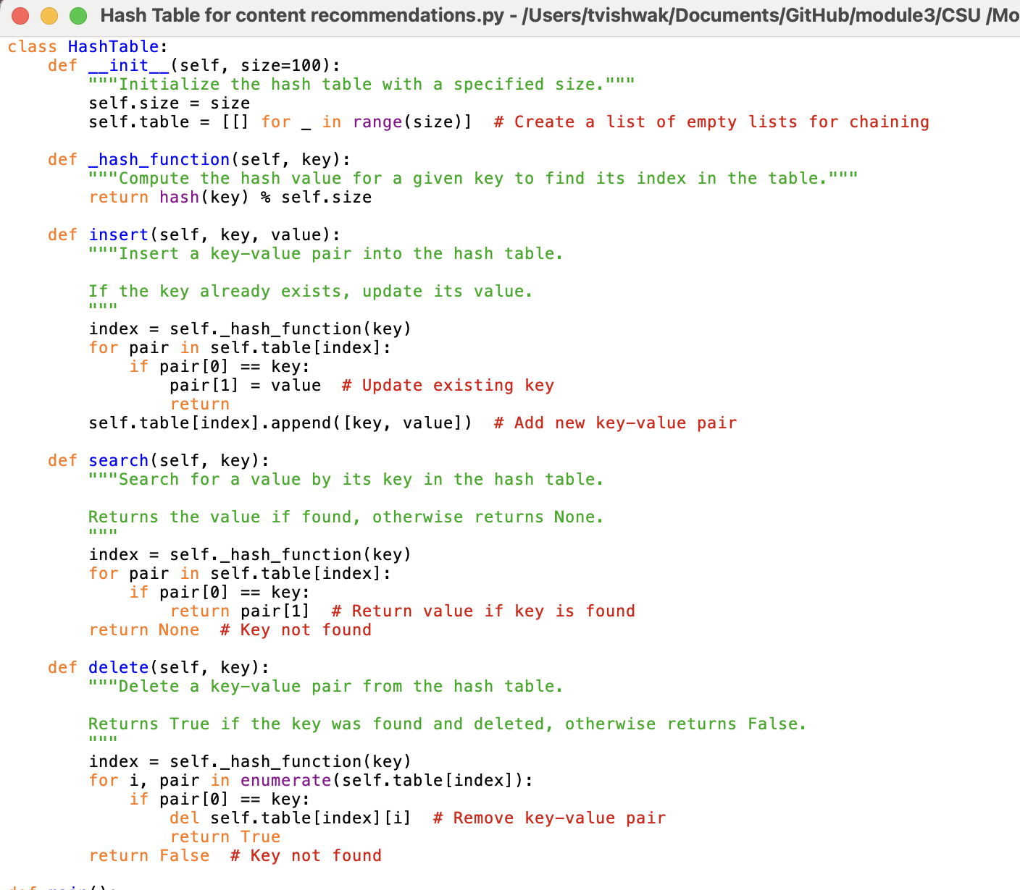

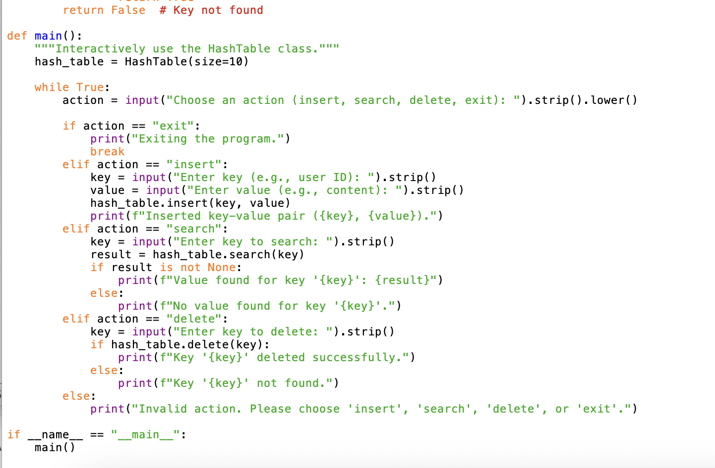

Execution-

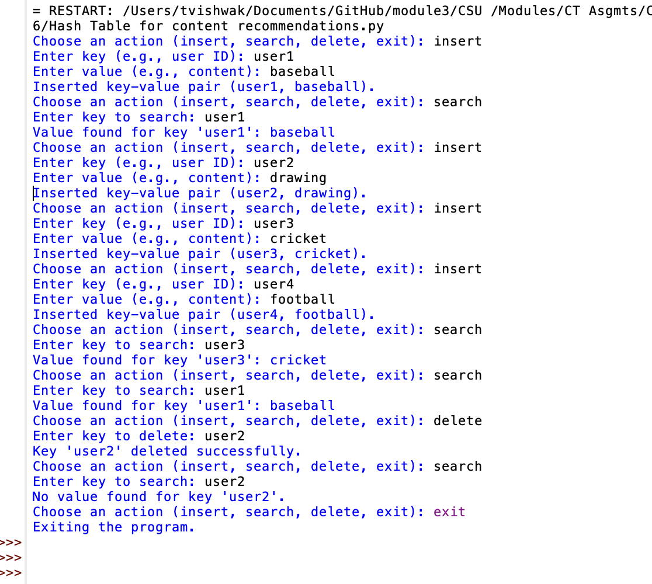

Conclusion
The implementation of a hash table for a social media content recommendation system demonstrates the potential for hash tables to efficiently manage large datasets and provide real-time updates. Despite challenges such as collision management and dynamic resizing, the project successfully enhanced understanding and skills in data structure implementation and algorithm design. Future work will focus on refining the hash function and exploring distributed hash table solutions for even greater scalability.

References
Cormen, T. H., Leiserson, C. E., Rivest, R. L., & Stein, C. (2009). Introduction to Algorithms (3rd ed.). MIT Press.
Knuth, D. E. (1998). The Art of Computer Programming, Volume 3: Sorting and Searching (2nd ed.). Addison-Wesley.
Weiss, M. A. (2011). Data Structures and Algorithm Analysis in Java (3rd ed.). Pearson.

